
TSXV: SGN
#750-1095 W. Pender St.
Vancouver, BC V6E2M6
WWW.SCORPIOGOLD.COM

Scorpio Gold Announces Option of Betty East Property, Extending Claim Package at Manhattan District, Nevada

January 15th, 2025 - Vancouver, British Columbia – Scorpio Gold Corporation (TSX-V: SGN, OTCQB: SRCRF, FSE: RY9) (“Scorpio Gold”, or the “Company”) is pleased to announce that it has entered into a property option agreement (the “Agreement”) with an arm’s length third party (the “Optionor”) and a wholly-owned subsidiary of the Company (the “Optionee”) to acquire a 100% interest in the thirty-two unpatented lode mining claims known as the Betty East Property, located in Nye County, Nevada (“Betty East” or the “Property”).

Details of the Property
Historically, the Property has seen limited exploration. Nevada Goldfields Inc. conducted shallow reverse-circulation drilling and trenching in the early 1990s, which identified near-surface gold mineralization at the Knolls area and outlined additional interpreted near-surface and deeper conceptual targets. Available historic data includes drill logs and results from fifteen shallow RC holes, trench mapping, detailed geological sections, and a historical geological report, which together suggest potential for both shallow oxide mineralization and a larger, structurally controlled mineralized system at depth.
More recent historic work on the at the Knolls, by Sierra Grande Minerals Inc., has been limited to a sample soil geochemical survey of approximately 290 samples. Initially,140 samples were taken in the south-central part of the claim block on a 650 m (north-south) and 325 m (east-west) grid of 50 m east-west spaced lines with samples taken between 25 m and 50 m along the lines. The results demonstrate a pronounced, north-south epithermal Au-As-(Ag-Hg) signature with locally very high Au soil results, including 6.27, 5.06, 1.19 and 0.69 g/t Au. This lies within an envelope of anomalous Au and As and extends to a background of <20 ppb gold.
Following this, the same company completed a northeast-southwest elongate grid of 150 samples taken on a nominal 100 m spacing, covering 1,300 m by 800 m. Sampled immediately to the northeast of The Knolls, this grid outlined a broad, east-northeast trending zone that is highly anomalous in As, Hg, Ag, Sb and Mo, along with locally elevated Au and consistently elevated Zn, Cu and W. The new, east-northeast trend is >1.5 km long, up to 1 km wide, and displays elements of both epithermal and intrusive-related signatures. All historic soil samples were analysed for gold by fire assay and multi-element ICP at ALS’s laboratory in Reno.
The Property is interpreted to be geologically contiguous with the southern portion of the Manhattan District, with mineralization occurring within favourable lower-plate sedimentary units associated with regional structural controls. Scorpio Gold has also staked additional claims between the Property and its existing Manhattan District land position, consolidating continuous claim coverage and enhancing the Company’s ability to systematically explore and test mineralized trends across the broader district.
“The Betty East option meaningfully expands our footprint at the southern end of the Manhattan District and gives us control of a highly prospective and underexplored part of the camp,” said Zayn Kalyan, CEO of Scorpio Gold. “Importantly, we have staked the intervening claims that connect Betty East to our existing claim block, creating continuous land tenure across a favourable geological corridor. This consolidation allows us to evaluate mineralized trends in a district-scale context, integrate historical work with modern exploration methods, and prioritize targets that may complement and extend the broader Manhattan mineral system. We see Betty East as a strategic addition that strengthens our long-term exploration optionality in one of Nevada’s most productive gold belts.”

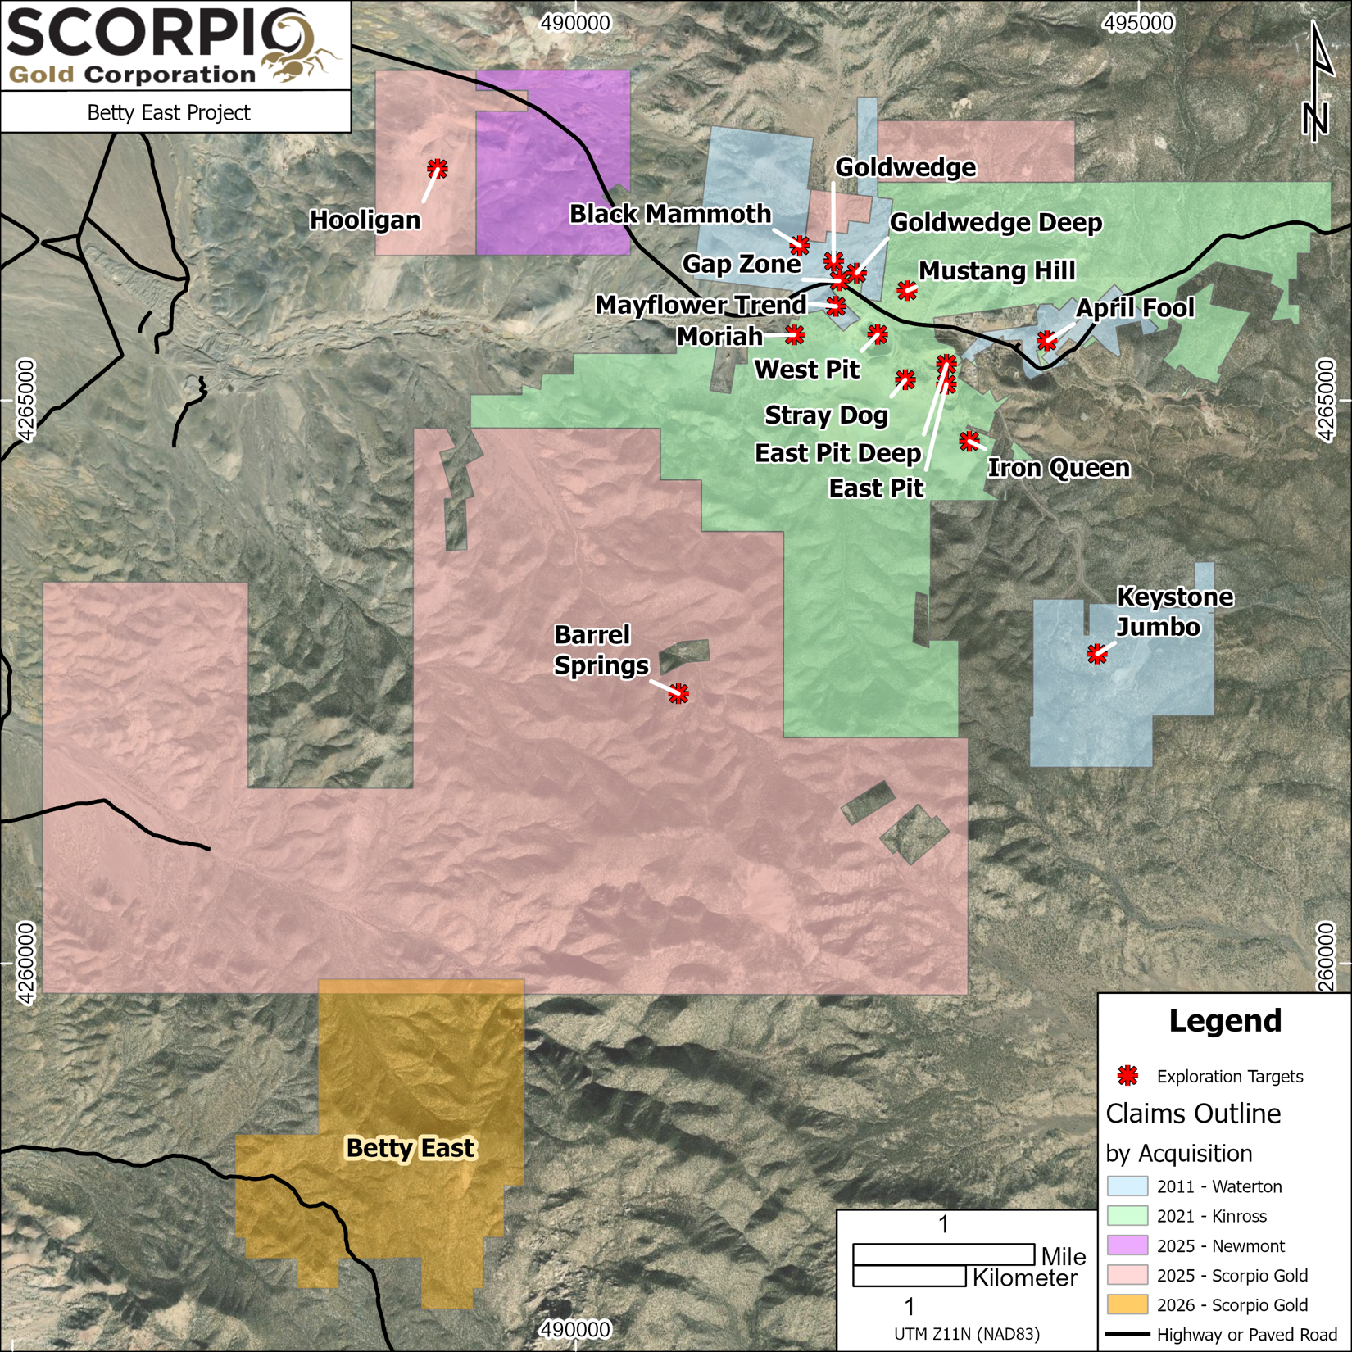
Figure 1: Map of Scorpio Gold claims including Betty East.

Terms of the Agreement

The Company, through the Optionee, has been granted the option to acquire 100% of the Property from the Optionor (the “Option”) by making staged cash and share payments totalling USD$900,000 and 950,000 common shares in the capital of the Company (the “Shares”) and incurring an aggregate of USD$1,000,000 in exploration expenditures on the Property over five years, as follows:

- USD$30,000 and 100,000 Shares within five days following the later of the effective date of the Agreement (the “Effective Date”) and the date on which the Company receives TSX Venture Exchange (“TSXV”) approval of the Agreement;
- USD$30,000 and 100,000 Shares on or before the 1st anniversary of the Effective Date;

- USD$$30,000, 150,000 Shares and USD$150,000 in exploration expenditures on or before the 2nd anniversary of the Effective Date;

- USD$50,000, 150,000 Shares and USD$200,000 in exploration expenditures on or before the 3rd anniversary of the Effective Date;

- USD$50,000, 200,000 Shares and USD$250,000 in exploration expenditures on or before the 4th anniversary of the Effective Date; and

- USD$710,000, 250,000 Shares and USD$400,000 in exploration expenditures on or before the 5th anniversary of the Effective Date.

Upon the exercise of the Option, the Optionor will be granted a 2% net smelter returns royalty (the “NSR Royalty) on the Property, with the Company retaining the right to buy back one-half (1%) of the NSR Royalty by paying the Optionor an amount equal to the value of 500 ounces of .999 fine gold.

The Agreement is subject to the approval of the TSXV.

Qualified Person
The scientific and technical information in this news release has been reviewed, verified and approved by Leo Hathaway, P. Geo., Chief Geologist of Scorpio Gold, a "Qualified Person", as defined under National Instrument 43-101 Standards of Disclosure for Mineral Projects. Verification included review of laboratory certificates, review of field logs and chain-of-custody records, inspection of blank/standard/duplicate performance, and review of collar and down-hole survey data. No limitations or failures to verify were identified.

About the Manhattan District
Manhattan, located in the Walker Lane Trend of Nevada, USA, is road accessible and lies approximately 20 kilometers south of the operating Round Mountain Gold Mine, which has produced more than 15 million ounces of gold. For the first time, the Company has consolidated Manhattan’s past-producing mines under a single entity that holds valuable permitting and water rights. Historically, Manhattan has produced approximately 700,000 ounces of gold from high-grade placer and lode operations dating from the late 1890s through to the mid-2000s.¹ The maiden mineral resource estimate (the “Maiden MRE”) covering the Goldwedge and Manhattan Pit areas of Manhattan is comprised of 18,343,000 tonnes grading 1.26 g/t gold for a total of 740,000 oz contained gold in the inferred category.²
A historical mineral resource estimate (the “Historical MRE”) covers the Black Mammoth, April Fool, Hooligan, Keystone, and Jumbo areas of Manhattan and comprises 1,652,325 tonnes grading 5.89 g/t gold for a total of 303,949 oz contained gold.³ The deposit is interpreted as a low-sulfidation, epithermal, gold-rich system situated adjacent to the Tertiary-aged Manhattan caldera in the Southern Toquima Range of Nevada. A “Qualified Person” as defined in National Instrument 43-101 - Standards of Disclosure for Mineral Projects (“NI 43-101”) has not done sufficient work to make the Historical MRE current, and the Company is not treating the Historical MRE as current.
Notes
- Adjacent Properties: The Company has no interest in, or rights to, any of the adjacent properties mentioned, including the Round Mountain Gold Mine, and exploration results on adjacent properties are not necessarily indicative of mineralization on the Company’s properties. Any references to exploration results on adjacent properties are provided for information only and do not imply any certainty of achieving similar results on the Company’s properties.

- Historical Data: This news release includes historical information that has been reviewed by the Company’s qualified person. The Company’s review of the historical records and information reasonably substantiate the validity of the information presented in this presentation. The Company encourages readers to exercise appropriate caution when evaluating these data and/or results.

- Third-Party Mineral Projects: These deposits are cited solely for geological context. The Company cautions that these properties are not necessarily adjacent to, nor does the Company or have any interest in or control over them. Although certain geological features may be similar, there is no assurance that mineralization comparable to these deposits will be discovered on any of the Company’s properties. Information regarding the aforementioned deposits is taken from publicly available sources and technical reports believed to be reliable, but has not been independently verified by the Company. The Company encourages readers to exercise appropriate caution when evaluating these data and/or results.

- Mineral Resource Estimate (MRE): All scientific and technical information relating to Manhattan pertaining to Maiden MRE contained in this news release is derived from the Technical Report dated October 23, 2025 (with an effective date of June 4, 2025) titled “Mineral Resource Estimate and NI 43-101 Technical Report” (the “Technical Report”) prepared by Matthew R. Dumala, P.Eng (BC) of Archer Cathro Geological (US) Ltd., Patrick Loury, M.Sc., CPG (AIPG) of Daniel Kunz & Associates, Annaliese Miller, LG (WA) of Geosyntec Consultants, Inc. and Art Ibrado, PhD, PE (AZ) of Fort Lowell Consulting PPLC. The information contained herein in respect of the Maiden MRE is subject to all of the assumptions, qualifications and procedures set out in the Technical Report and reference should be made to the full text of the Technical Report, a copy of which has been filed with the applicable securities regulators and is available under the Company’s profile on www.sedarplus.ca.

- Historical MRE: A Qualified Person has not done sufficient work to make the Historical MRE current, and the Company is not treating the Historical MRE as current.

The Company considers the Historical MRE relevant as it demonstrates the presence of significant gold mineralization across multiple zones within Manhattan; however, its reliability is uncertain because it was prepared prior to the adoption of the current CIM Definition Standards and current QA/QC practices. The Historical MRE provides limited disclosure of assumptions, parameters, estimation methods, cutoff grades, and QA/QC protocols, and therefore these cannot be fully verified by the Company. The categories used in the historical estimate predate, and are not directly comparable to, current CIM Definition Standards, and the Company is not treating the Historical MRE as a current Mineral Resource Estimate. To upgrade and verify the Historical MRE in order to make it a current Mineral Resource Estimate, the Company would be required to undertake confirmatory drilling, modern QA/QC sampling, validation and digitization of historical datasets and updated geological modeling followed by the preparation of a new Mineral Resource Estimate in accordance with CIM Definition Standards and NI 43-101. The Company encourages readers to exercise appropriate caution when evaluating the Historical MRE.

All scientific and technical information relating to Manhattan pertaining to the Historical MRE contained in this news release is derived from the Technical Report dated May 1997 titled “Exploration and Pre-Production Mine Development, Manhattan District Project, Nye County” (the “Historical Technical Report”) prepared by New Concept Mining, Inc.. The information contained herein in respect of the Historical MRE is subject to all of the assumptions, qualifications and procedures set out in the Historical Technical Report and reference should be made to the full text of the Historical Technical Report.

- References: (1) Strachan, D. G., and Master, T. D., 2005: Update and Revision of the Gold Wedge Project Development, Nye County. Report prepared for Nevada; Royal Standard Minerals, Inc. and dated March 31, 2005; (2) Dumlala, M. R., and Lowry, P., 2025: Mineral Resource Estimate and NI 43-101 Technical Report, Manhattan Property, Nye County, Nevada. Report prepared for Scorpio Gold Corporation and dated October 23, 2025 (with an effective date of June 4, 2025); and (3) Berry, A., and Willard, P., 1997: "Exploration and Pre-Production Mine Development, Manhattan District Project, Nye County". Report prepared for New Concept Mining, Inc. and dated May 1997.

ON BEHALF OF THE BOARD OF SCORPIO GOLD CORPORATION
Zayn Kalyan, Chief Executive Officer and Director
Tel: (604)-252-2672
Email: zayn@scorpiogold.com
Investor Relations Contact:
Kin Communications Inc.
Tel: (604) 684-6730
Email: SGN@kincommunications.com
Connect with Scorpio Gold:
Email | Website | Facebook | LinkedIn | X | YouTube
To register for investor updates please visit: scorpiogold.com
TSXV: SGN | OTC: SRCRF | FSE: RY9
Forward-Looking Statements
The Company relies on litigation protection for forward-looking statements. This news release contains forward-looking statements that are based on the Company’s current expectations and estimates. Forward-looking statements are frequently characterized by words such as “plan”, “expect”, “project”, “intend”, “believe”, “anticipate”, “estimate”, “suggest”, “indicate” and other similar words or statements that certain events or conditions “may” or “will” occur, and include, without limitation, statements regarding: the Company's exploration plans and ability to systematically test mineralized trends; the work required to upgrade or verify the Historical MRE to a current mineral resource; the intention of the Company to make all payments towards the Option and to exercise the Option on the terms and conditions set out under the Agreement; and the approval of the TSXV for the Agreement. There is significant risk that the forward-looking statements will not prove to be accurate, that the management’s assumptions may not be correct and that actual results may differ materially from such forward-looking statements. Such forward-looking statements involve known and unknown risks, uncertainties and other factors that could cause actual events or results to differ materially from estimated or anticipated events or results implied or expressed in such forward-looking statements, including those risk factors outlined in the Company’s Management Discussion and Analysis as filed on SEDAR+. Any forward-looking statement speaks only as of the date on which it is made and, except as may be required by applicable securities laws, the Company disclaims any intent or obligation to update any forward-looking statement, whether as a result of new information, future events or results or otherwise. Forward-looking statements are not guarantees of future performance and accordingly undue reliance should not be put on such statements due to the inherent uncertainty thereof.
Neither the TSX Venture Exchange nor its Regulation Services Provider (as that term is defined in the policies of the Exchange) accepts responsibility for the adequacy or accuracy of this release.

https://www.newswire.ca/news-releases/soil-geochemistry-results-highlight-exciting-new-targets-at-sierra-s-betty-east-property-western-nevada-869074092.html

